Lab 1.2 Worksheet Sample

1. How many cases are there? How many variables? For each variable, identify its data type (e.g. categorical, numerical).

**There are 14041 observations and 26 variables.**

1. Comment on your plots. Is this what you expected to see? 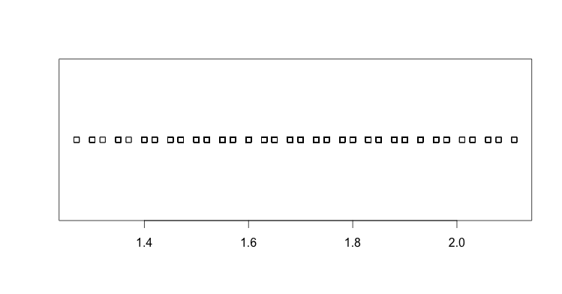

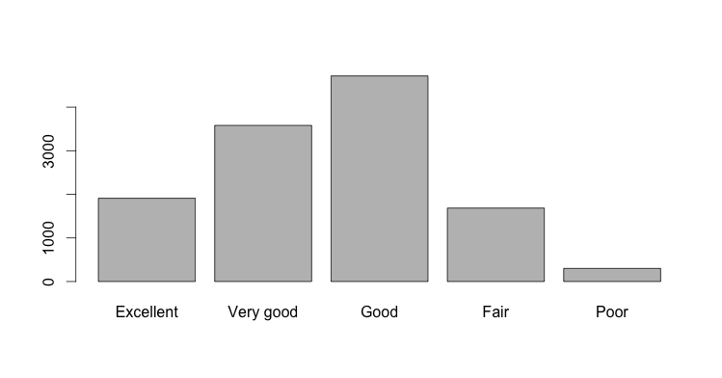

1. What story can you tell about the relationship between height and weight?

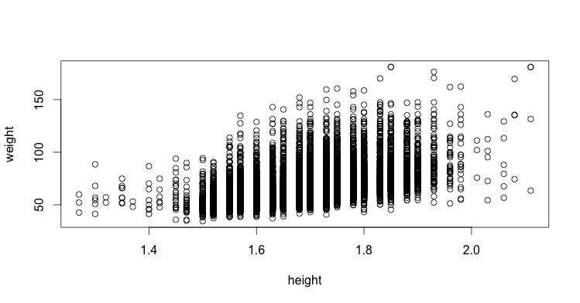

1. How many plots there are in your plot? Can you guess why? Also, can you guess the type of the plots?

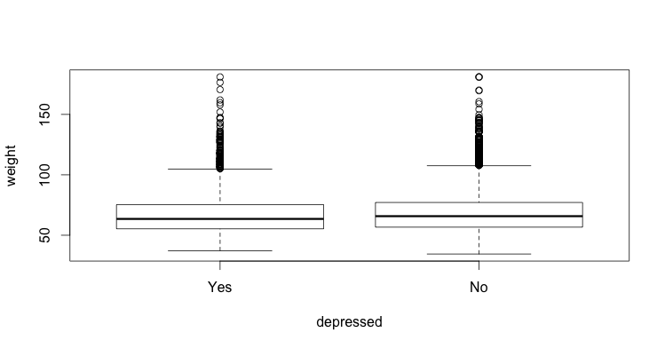

1. Describe what you see. Why do you think there are 5 segments in each bar?

